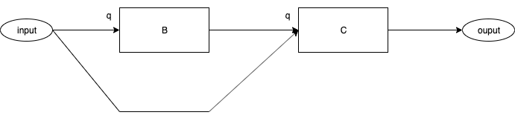
Fig. <$n:figure:SyncVsAsync_SyncControlFlow> After Event Delivery 1

Fig. <$n:figure:SyncVsAsync_SyncControlFlow> shows what the system looks like after Event Delivery 1 has occurred.

Both, Components B and C have an event "q" at their inputs.

(Neither Component has acted yet).

